*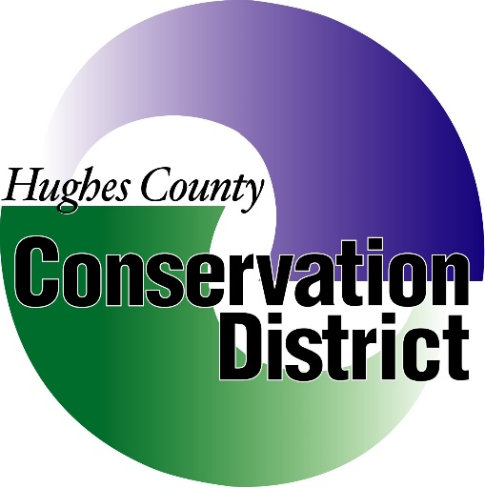****Hughes County Conservation District***

***1717 N. Lincoln Ave. Suite 103 Pierre, SD***

***December 10TH, 2020 at 7pm***

***Call the Meeting to Order:***

***Conflict of Interest affirmations:***

***Minutes of the October 7thMeeting:***

***Treasurers Report and Reconciliation*:**

* **Payments/ Invoices**
* **Approve and Sign Checks**
* **270 Day Account Report**

**Old Business:**

* **District Operations**
* **Customer Accounts RL018, DM020**
* **Soil Conservation Farm/Ranch Award Winners and Presentations**
* **SCCD Finance Charges**

**New Business:**

* **Grant Award & Acceptance Form (Dept of Ag)**
* **Agassiz - Green Strip Fabric**
* **2020 IWLA Wildlife Habitat Award**
* **2020 Christmas Party**
* **Fabric Order**
* **Tree Planting Outlook**
* **Employee Health ins.**
* **NACD National Meeting (Virtual)**
* **2020 Covid-19 Expenses**
* **Advertisement Rate**
* **Cannabis Growers**
* **Corn Planter**
* **Employee’s Yearly Evaluation**
* **Down Payment Rates**
* **SDACD & Conservation Commission**
* **Arbor Day**
* **Christmas Bonuses**

**Executive Session:**

**Pursuant to Executive Session 1-25-2.4.**

**Secretary’s Report:**

* **HCCD Grant Approval**

**Manager’s Report:**

* **Workload Update**
* **1590 tires**
* **2nd trailer repair**

**Field Office Report:**

* **Trevis Olson**

**Plans for Review:**

* **Trevis Olson**

**Next Meeting Date:**

**Join by Phone:**

* **Call 1-605-280-3021/605-280-6715**