*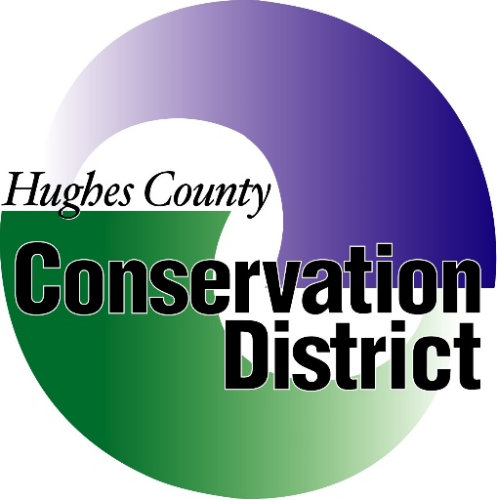****Hughes County Conservation District***

***1717 N. Lincoln Ave. Suite 103 Pierre, SD***

***July 8TH, 2020 at 1pm***

***Call the Meeting to Order:***

***Conflict of Interest affirmations:***

***Minutes of the June 11thMeeting:***

***Treasurers Report and Reconciliation*:**

* **Payments/ Invoices**
* **Approve and Sign Checks**

**Old Business:**

* **HCCD Debit/Credit Card**
* **Elections**
* **Sully County Discussion**
* **District Operations**
* **County Contract**
* **Customer Account RL018/JJ020**
* **Conservation Award Winners and Presentations**

**New Business:**

* **Tree/Fabric Price Increase**
* **Pickup Reports/Insurance Claims**
* **Employee Status**
* **Secretary**

**Executive Session:**

**Pursuant to Executive Session 1-25-2.4.**

**Secretary’s Report:**

**Manager’s Report:**

* **Workload Update**
* **Vacation**

**Field Office Report:**

* **Dillion Blaha & Trevis Olson**

**Plans for Review:**

* **Dillion Blaha & Trevis Olson**

**Next Meeting Date:**

**Join by Phone:**

* **Call 1-214-459-3653 Meeting Number 963 493 322**

**Join from a Video System:**

* [**963493322@hughesccd.webex.com**](mailto:963493322@hughesccd.webex.com) **Meeting Password CGkBJRrY373**