HUGHES COUNTY CONSERVATION DISTRICT

# 2025 TREE ORDER FORM

Thank you for choosing the Hughes County Conservation District for your Spring tree and

landscape needs! Please fill out the Customer Information and return the completed order packet to the office via in-person drop off, return mail, or scan/email. We will enter your order and create an invoice for you, which we will update you with.

If you don’t see a tree/plant species you are specifically looking for, please reach out and we can try to find it for you!

All orders over $500.00 will require a 50% deposit when order is placed.

Customer Name: Date: Address: City, State, Zip: Phone: Email:

## TREE INITIATIVE GRANT OPPORTUNITY

Interested in renovating or installing new windbreaks/livestock shelterbelts? HCCD has a grant to provide up to 50% cost-share to producers within Hughes County. HCCD will provide technical assistance as well, helping to create a tree plan with you and providing tips for tree establishment.

If you are interested, please reach out via phone or email!

## WE ARE HIRING!

We are looking to fill positions for a District Manager, Office Manager and Tree Crew Members. Please reach out if you would like more details!

1717 Lincoln Ave, Suite 103

Pierre, SD 57501

Office Phone: (605)-301-3401 Email: [hughesccd@gmail.com](mailto:hughesccd@gmail.com)

Chairman - Terry Ness

Vice Chairman - Lyle Stewart Secretary/Treasurer - Brent Pries Supervisor - Darrell Metzinger Supervisor - Jesse Foster

*THE HUGHES COUNTY CONSERVATION DISTRICT RESERVES THE RIGHT TO CANCEL ANY PORTION OF THE AMOUNT REQUESTED OR ALL THEREOF. THE DISTRICT GIVES NO WARRANTY, EXPRESSED OR IMPLIED AND WILL UNDER NO CIRCUMSTANCES BE LIABLE FOR MORE THAN THE INVOICE AMOUNT LISTED AFTER THE PURCHASE. NO CANCELLATIONS.*

|  |  |  |  |  |  |  |  |
| --- | --- | --- | --- | --- | --- | --- | --- |
| **BAREROOT HARDWOODS** | | | | | | | |
| $3.00 each or $65/bundle of the same species (25 trees/bundle) | | | | | | | |
| **Amt.** | **Species** |  | **Amt.** | **Species** |  | **Amt.** | **Species** |
|  | Almond, Russian |  | Crabapple, Siberian |  | Linden, Little Leaf |
|  | Apricot |  | Currant, American Black |  | Maple, Amur |
|  | Aronia, Black |  | Currant, Golden |  | Maple, Silver |
|  | Aspen, Quaking |  | Dogwood, Redosier |  | Mulberry |
|  | Birch, River |  | Elderberry, Common |  | Ninebark, Common |
|  | Boxelder |  | Elm, American |  | Oak, Bur |
|  | Buckeye, Ohio |  | Hackberry |  | Pear, Harbin ‘McDermand’ |
|  | Buffaloberry |  | Hawthorn, Homestead |  | Plum, American |
|  | Caragana |  | Hawthorn, Roundleaf |  | Plum, Prairie Red |
|  | Catalpa, Northern |  | Hazelnut, American |  | Poplar, White |
|  | Cherry, Black |  | Hickory, Shagbark |  | Rose, Hansen Hedge |
|  | Cherry, Nanking |  | Honeylocust, Thornless |  | Rose, Rugosa |
|  | Cherry, Sand |  | Honeysuckle |  | Rose, Woods |
|  | Chokecherry, Amur |  | Honeysuckle, Hawkeye |  | Sumac, Skunkbush |
|  | Chokecherry, Schubert |  | Indigo, False |  | Sumac, Smooth |
|  | Cotoneaster, Centennial |  | Juneberry |  | Sycamore |
|  | Cotoneaster, Peking |  | Kentucky Coffee Tree |  | Viburnum, Nannyberry |
|  | Cottonwood, Hybrid Male |  | Lilac, Common |  | Walnut, Black |
|  | Cottonwood, Native |  | Lilac, Villosa |  | Willow, Diamond |
|  | Crabapple, Midwest |  | Lilac, White |  | Willow, Golden |
|  | Crabapple, Red Splendor |  | Linden, American |  | Willow, Hybrid |

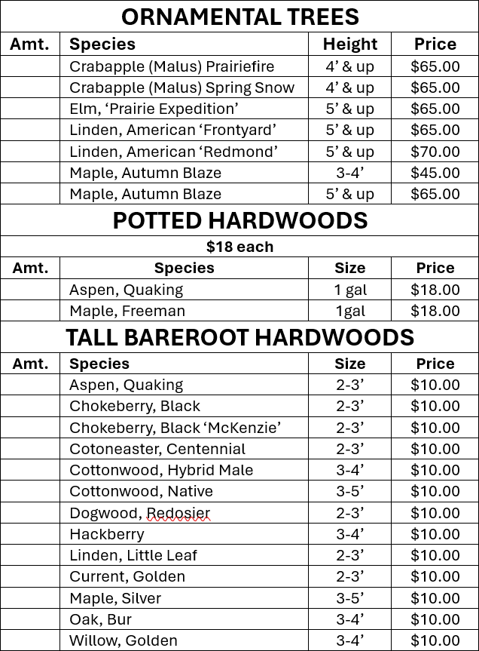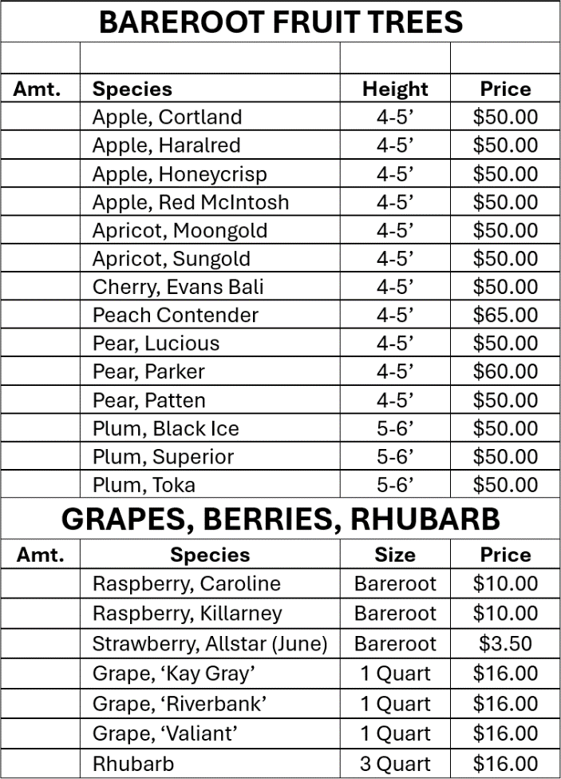

*DEPENDING ON AVAILABILITY, PRICES AND SIZES MAY CHANGE. THE EARLIER YOU ORDER, THE BETTER ODDS OF US SECURING YOUR DESIRED SPECIES AND SIZE!*

|  |  |  |  |  |  |  |  |  |
| --- | --- | --- | --- | --- | --- | --- | --- | --- |
| **BAREROOT CONIFERS** | | | |  | **POTTED CONIFERS** | | | |
| **Amt.** | **Species** | **Size** | **Price** | **Amt.** | **Species** | **Size** | **Price** |
|  | Cedar, Eastern Red | 2-0 | $3.00 |  | Cedar, Eastern Red | 1 gal | $25.00 |
|  | Cedar, Eastern Red | 3-0 | $3.00 |  | Juniper, Rocky Mountain | 1 gal | $25.00 |
|  | Juniper, Rocky Mountain | 2-0 | $3.00 |  | Fir, Douglas | 1 gal | $25.00 |
|  | Juniper, Rocky Mountain | 3-0 | $3.00 |  | Larch, Siberian | 1 gal | $25.00 |
|  | Pine, Austrian | 3-0 | $3.00 |  | Pine, Austrian | 1 gal | $25.00 |
|  | Pine, Ponderosa | 2-0 | $3.00 |  | Pine, Ponderosa | 1 gal | $25.00 |
|  | Pine, Ponderosa | 3-0 | $3.00 |  | Pine, Ponderosa | 3 gal | $45.00 |
|  | Pine, Scotch | 2-0 | $3.00 |  | Pine, Scotch | 1 gal | $25.00 |
|  | Pine, Scotch | 3-0 | $3.00 |  | Spruce, Black Hills | 1 gal | $25.00 |
|  | Spruce, Black Hills | 2-2 | $3.00 |  | Spruce, Black Hills | 3 gal | $45.00 |
|  | Spruce, Colorado | 2-2 | $3.00 |  | Spruce, Colorado | 1 gal | $25.00 |
|  | Spruce, Meyer | 4-0 | $3.00 |  | Spruce, Meyer | 1 gal | $25.00 |
|  | Spruce, Norway | 3-0 | $3.00 |  | Spruce, Norway | 1 gal | $25.00 |
| **STYRO CONIFERS** | | | | **OTHER SUPPLIES AND PRODUCTS** | | | |
| Similar to how you purchase tomatoes, containers  are ~ 1”x3” | | | | Anything you may need to support new trees, gardens,  grass seedings, etc. | | | |
| **Amt.** | **Species** | **Price** | | Amt. | Item | | Price |
|  | Cedar, Eastern Red | $4.50 | |  | Plantskydd, Concentrate | 1lb | $35.00 |
|  | Fir, Douglas | $4.50 | |  | Plantskydd, Concentrate | 2.2 lb | $60.00 |
|  | Pine, Austrian | $4.50 | |  | Plantskydd, Ready to Use | 1 Qt | $23.00 |
|  | Pine, Ponderosa | $4.50 | |  | Plantskydd, Granular Shaker | 1 lb | $15.00 |
|  | Pine, Scotch | $4.50 | |  | Plantskydd, Granular Shaker | 2 lb | $20.00 |
|  | Spruce, Black Hills | $4.50 | |  | Fabric, 4’ X 300’ | | $125.00 |
|  | Spruce, Colorado | $4.50 | |  | Fabric, 6’ X 750’ | | $300.00 |
|  | Spruce, Meyer | $4.50 | |  | Fabric, 4’ X 4’ Square | | $5.00 |
|  | Spruce, Norway | $4.50 | |  | Sod Staples 8” X 2”X 8” | Single | $0.40 |
|  | | | | |  | Sod Staples 8” X 2”X 8” | Box 500 | $150.00 |
|  | 4’ Tree Tube | Single | $6.50 |
|  | 5’ Tree Tube | Single | $7.50 |

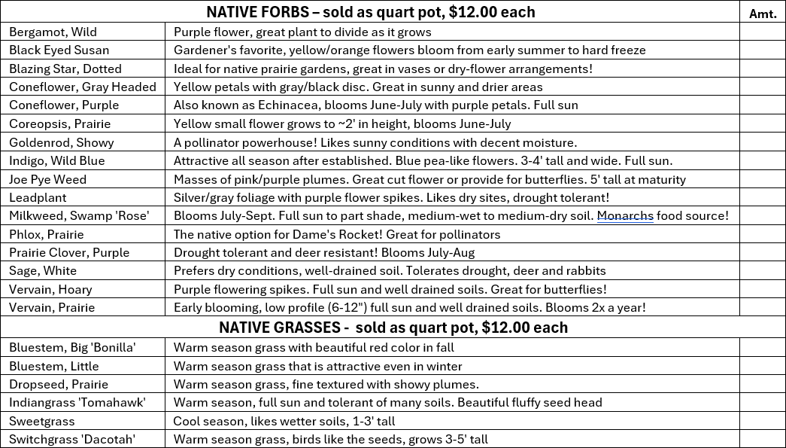

HUGHES COUNTY CONSERVATION DISTRICT

# 2025 SERVICES SHEET

HCCD Manager (605) 280-3021 (c)

HCCD Secretary (605) 301-3401 (c) or (605) 280-6715 (o)

### HCCD Hired Tree Services

HCCD tree planting (with tractor and crew) $1.00/foot

*this price includes cost of trees and planting

*$200.00 minimum charge

HCCD fabric installation (with tractor and crew) $1.50/foot

*this price includes cost of fabric and installation

*$200.00 minimum charge

HCCD hand planting (staff plants trees for you)

Conservation Grade Trees. $2.50/tree

Potted Trees. $12.00/tree

Tall Bareroot Trees. $25.00/tree

*there is a $125.00 daily site fee

### HCCD No-Till drill Seeding Services

$300.00 minimum charge

Current federal mileage rate will be applied to each site, each visit

Hughes County Customers:

Complete Service (drill + operator). $25.00/acre

*there is a $300.00 one-time site fee

Customers outside of Hughes County (MUST REACH OUT FOR QUOTE)

Complete Service (drill + operator). $30.00/acre

*there is a $300.00 site fee plus $50.00 per additional county traveled through

### HCCD Other Hired Services

Rototilling, Ripping and Mowing Services. $130.00/hour

*$260.00 minimum charge

### Equipment Available to Rent

Kasco Drill/Trailer. $45.00/hour OR $300.00/24 hours

4" OR 6" Auger. $40.00/hour OR $40.00/24 hours

Water Wagon. $45.00/hour OR $300.00/24 hours

4' Fabric Machine. $25.00/hour OR $50.00/24 hours

All prices are subject to change at any time.