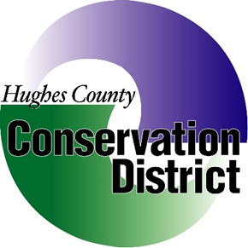

*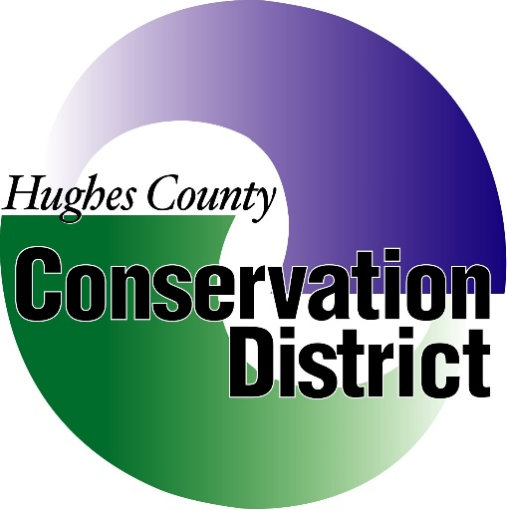****Hughes County Conservation District***

***1717 N. Lincoln Ave. Suite 103 Pierre, SD***

***December 5TH, 2019 at 3pm***

***Call the Meeting to Order:***

***Conflict of Interest affirmations:***

***Minutes of the November 14thMeeting:***

***Treasurers Report and Reconciliation*:**

* **Payments/ Invoices**
* **Approve and Sign Checks**

**Old Business:**

* **Certified Letters/Small Claims**
* **Sully County Discussion**
* **Oath of Office**
* **AFLAC**
* **District Operations**
* **Arbor Day Membership Renewal**

**New Business:**

* **2019 Contour Lines**
* **2018/19 Letter to Cons. Committee**
* **Moa and Unfunded Coop Agreement**
* **NACD Membership**
* **Talk about JF’s Planting**
* **SD Tree Planting Reports**
* **Forest Action Plan Comments**
* **Soil Conservation Farm/Ranch Award (5) per year**
* **2020 National Convention – Champions Scholarship**
* **2019 Convention Registrations**
* **Christmas Season Bonus’**
* **Employee’s Holiday Leave dates.**

**Executive Session:**

**Pursuant to Executive Session 1-25-2.4.**

**Secretary’s Report:**

**Manager’s Report:**

* **Workload Update**
* **Grant – Contract Reports**

**Field Office Report:**

* **Dillion Blaha & April Boltjes**

**Plans for Review:**

* **Dillion Blaha & April Boltjes**

**Next Meeting Date:**